|  |
| --- |
| Developer Documentation |
| Hela Weda Piyasa Ayurwedic Hospital  Team Software Project – Group 08  Level – 3  Department of Computer Science  Faculty of Science  University of Jaffna |
|  |

**Contents**

**Executive Summary -------------------------------------------------------- 2**

**Team information ----------------------------------------------------------- 6**

**Software License ------------------------------------------------------------ 6**

**Installing Softwares -------------------------------------------------------- 7**

**Set up .env ------------------------------------------------------------------- 19**

**Basic codes ------------------------------------------------------------------ 20**

**How to clone the project from github repository --------------- 20**

**URLs and methods -------------------------------------------------------- 21**

**Database models----------------------------------------------------------- 30**

**Controllers ------------------------------------------------------------------- 31**

**Test Cases ------------------------------------------------------------------- 32**

**Executive Summary**

* **Outcome to be achieved**

At present, there are lots of private hospitals are available to provide medical services. People are seeking private hospitals as they believe that the private hospitals are providing higher quality treatment than government hospitals. This is the online system that can bring more advantages for the doctors, patients etc.

* **Users**

There are mainly 5 users. They are Patient, Doctors, Pharmacist, Medicine Producers, Ingredient suppliers. Additionally, there is an admin also available to control some particular activities.

* **Problem Statement**
* **Patients**
* Nowadays, if a patient wants to see a doctor, they should book before. So they need to visit to hospital and book.
* If they want to buy medicines they need to go to that pharmacy.
* There is no way to send their current condition to corresponding doctors.
* Now, we have clinic books to see past histories. In case, if the book is missed, no way to get back

.

* **Doctors**
* Normally, doctors write prescription in papers. So patient should carry the paper to pharmacist.
* To keep admitted patient record we need to maintain a big ledger book.
* Doctors want to update the admitted patient records to give medicines to them.
* If doctor will be late or unable to come, he should inform to the staffs.
* Doctor doesn’t aware himself how many patients are going to come today.
* **Pharmacist**
* Pharmacist is not aware of medicine stocks. When will be expired? , how many stocks are there?
* Pharmacist should ask with patient the prescription or medicine details and he need to calculate the bill.
* Pharmacists are unaware about the amount of medicines and expiry date of medicines available in the stock.
* **Medicine Producer**
* He should maintain a medicine table manually.
* He should maintain ingredient table manually.
* If he creates a new medicine he should acknowledge to pharmacists.
* When ingredients finish in stock he will say to suppliers.
* He may be forgotten to issue order. So he should maintain orders table manually also which is from pharmacist.
* **Ingredient Suppliers**
* He should manage what ingredients stock has and maintain orders from producers.
* **Solution**

* **Patients**
* Patients can simply book a doctor and order medicines from anywhere rather than go directly to the hospital.
* They can send their symptoms, as text, images even as audio file.
* No need to check any clinic books to see what the doctor said in last meeting.
* **Doctors**
* Doctors can pass the prescription to pharmacist via online.
* Patients can be admitted at hospital via/through this system.
* Daily updates also can be added through system.
* Doctors can see patients’ symptoms through this system and they can suggest the solution.
* Simply they can watch how many appointments they have today.
* They can update the availability time.
* **Pharmacists**
* Pharmacists are going to aware of medical stock through this system.
* They don’t need to calculate the bill amount. System will do.
* They can see the requested orders from patients and doctors.
* They can order medicines via online to medicine producer.
* **Medicine Producer**
  + Medicine and ingredient table will be maintained in their database.
  + He can able to acknowledge to pharmacist, when pharmacist requires new medicine.
  + Orders from pharmacist will be maintained.
  + Producer can place order to supplier when ingredients are finished.
* **Ingredient Supplier**
* Supplier can manage his ingredient stocks and can see the ingredients order details from medicine producer.

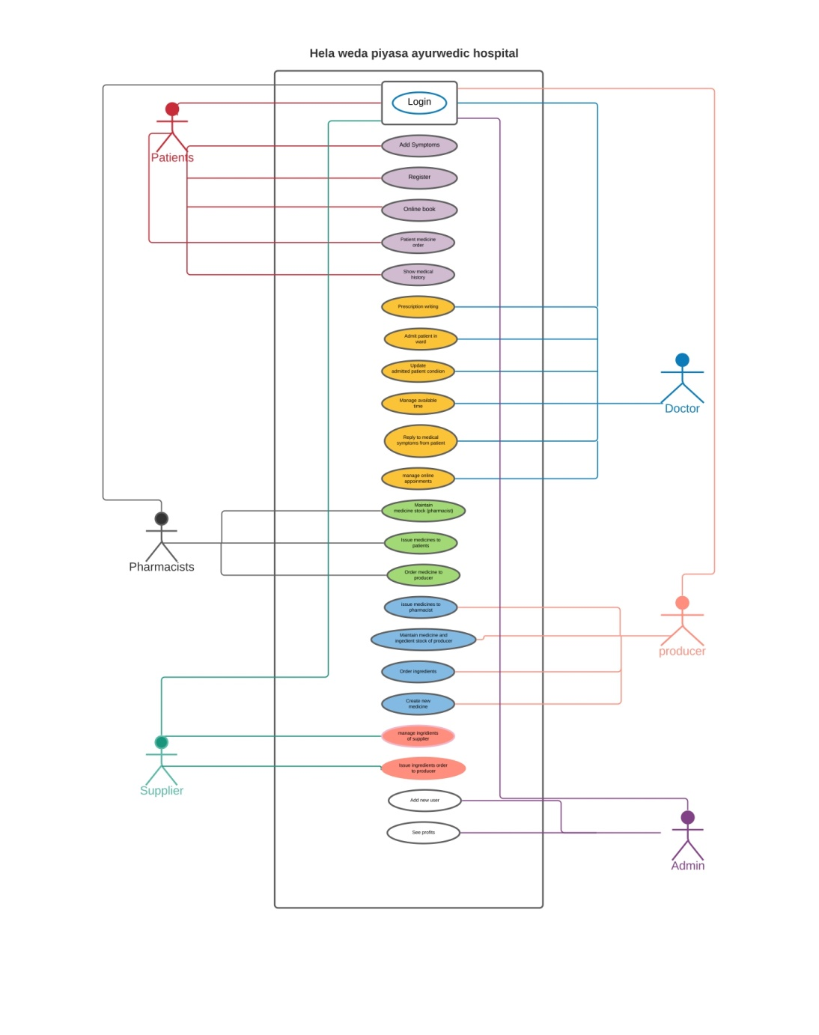**Usecase DiagramTeam Information**

This web system is developed by the following team members.

1. Elackshana M. - [elackshana@gmail.com](mailto:elackshana@gmail.com) 2017CSC018(Database Design)
2. P.A.Gamage. - [ajanthasirigamage@gmail.com](mailto:ajanthasirigamage@gmail.com) 2017CSC033(App Development)
3. Dilki Hasara - [dhwways@gmail.com](mailto:dhwways@gmail.com) 2017CSC022(UI Design)
4. S. lokavannilavan - [lokavan007@gmail.com](mailto:lokavan007@gmail.com) 2017CSC047(System Testing)
5. ULM Afrid - [mafrid029@gmail.com](mailto:mafrid029@gmail.com) 2017CSC029 (Team Leader)

Github Repository link : <https://github.com/afrid029/TeamSoftwareDevelopmentGroup08.git>

Blog : [Click Here](https://umafd.blogspot.com/2021/04/hela-weda-piyasa-ayurwedic-hospital.html)

Mentor: Ms. Samantha Tharani Jayakumar.

**Software License**

We are using following softwares.

* PHP – version 7.4.10
* Laravel – version 4.1.1
* Composer – version 1.10.13
* Apache – version 2.0
* Microsoft Visual Studio Code – version 1.52.1
* Mysql – version 10.4.14

**Installing Softwares**

* **Installing PHP, Apache, Mysql**

Above three softwares will be installed by install **XAMPP**

Download XAMPP here: <https://www.apachefriends.org/index.html>

**Install XAMPP on windows**

Press **Next>**

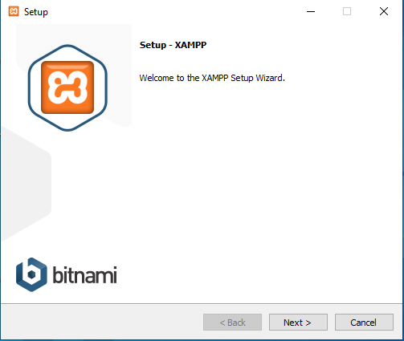

Press **Next>**

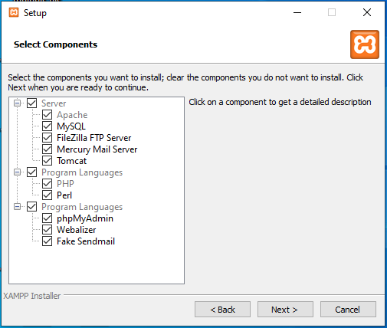

Select a folder to install and press **Next>**

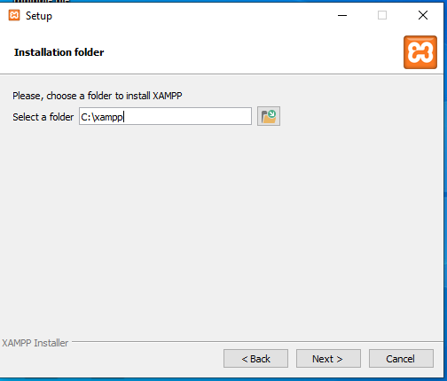

Select Language and press **Next>**

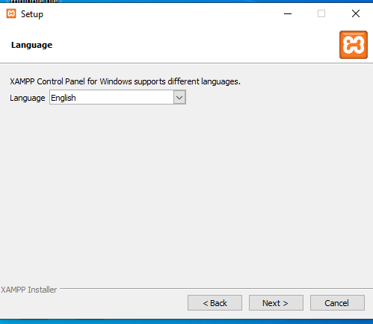

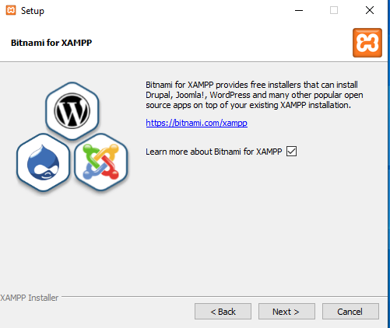

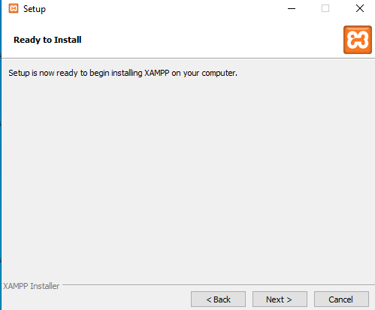

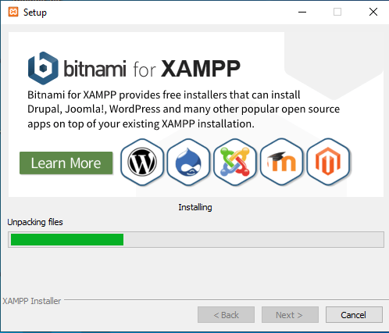

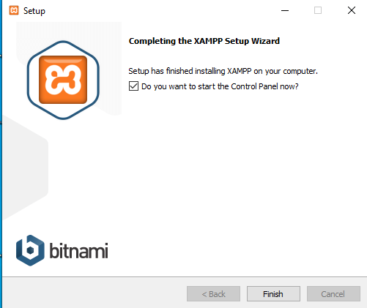

Check whether it is installed or not

Open **cmd**  and type **php –v** to check the version of php

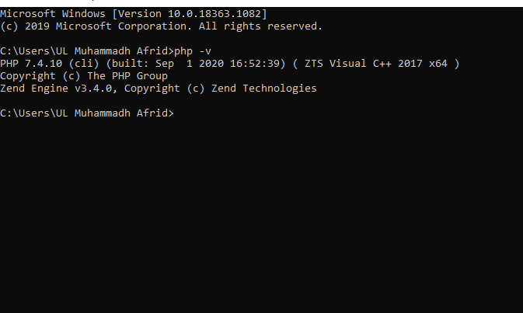

* **Installing Microsoft VS Code for windows**

We use MS VS code as our code editor.

Download the software in : <https://code.visualstudio.com/\>

* **Agree** the agreement and start to install

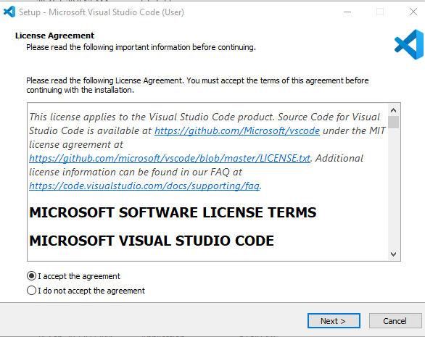

* Choose the **path** to install

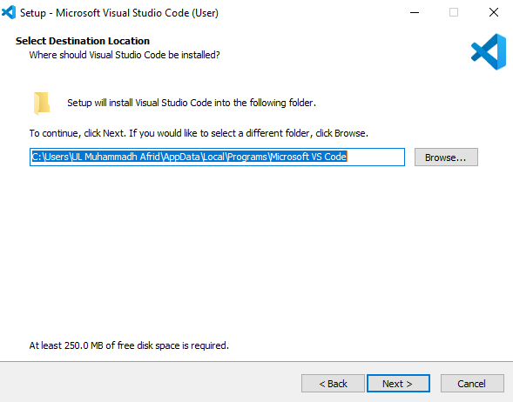

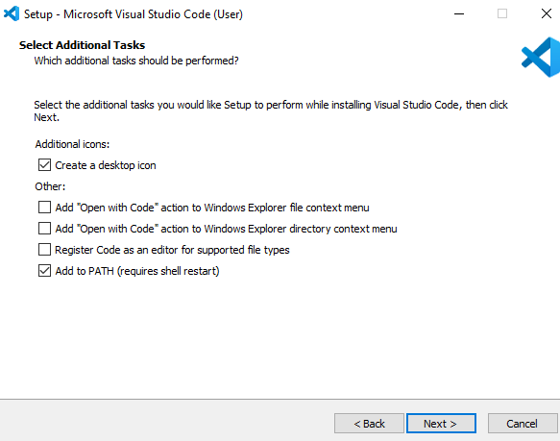

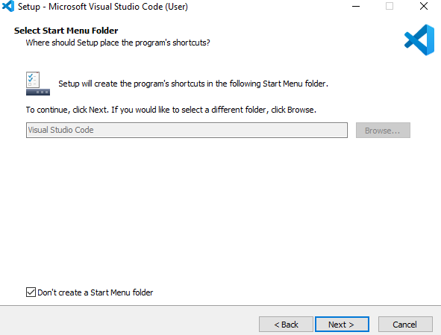

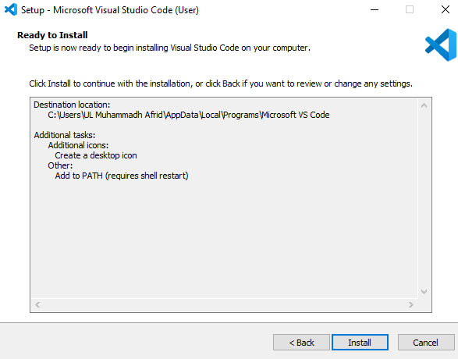

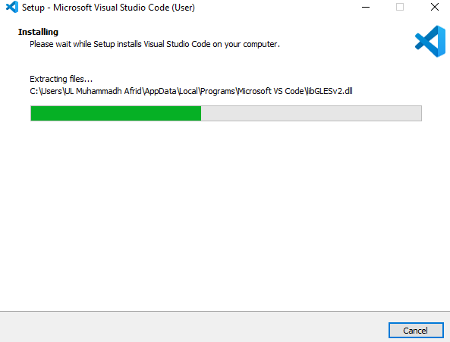

* 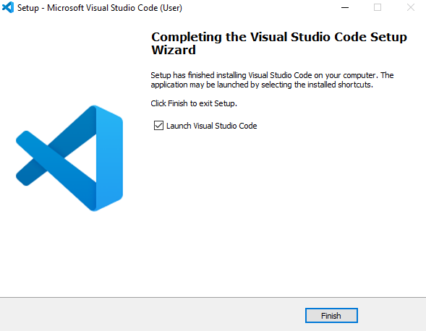**Installing Composer**

Composer is a dependency manager which contains libraries.

It is used to install packages like laravel framework, Doctrine, lodash etc..

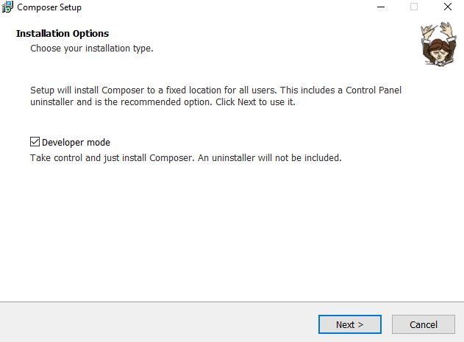

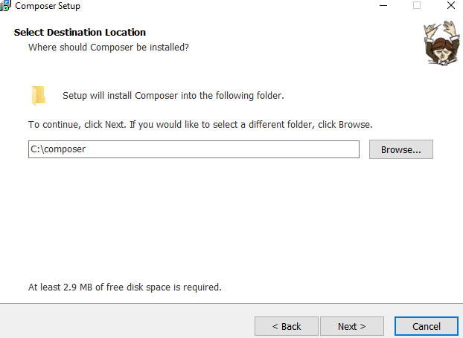

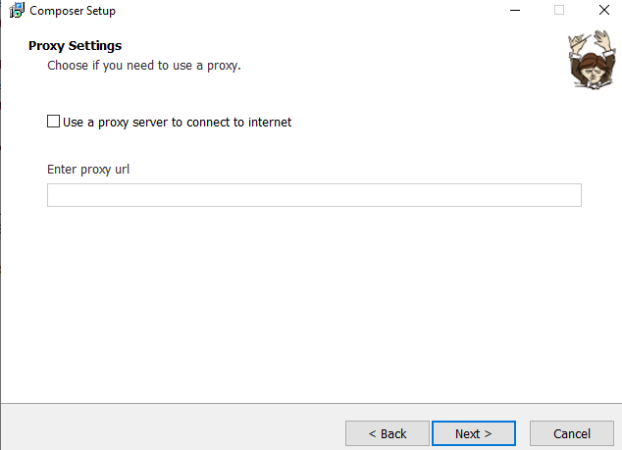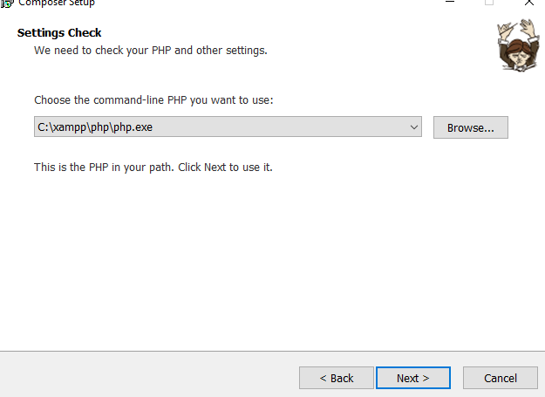

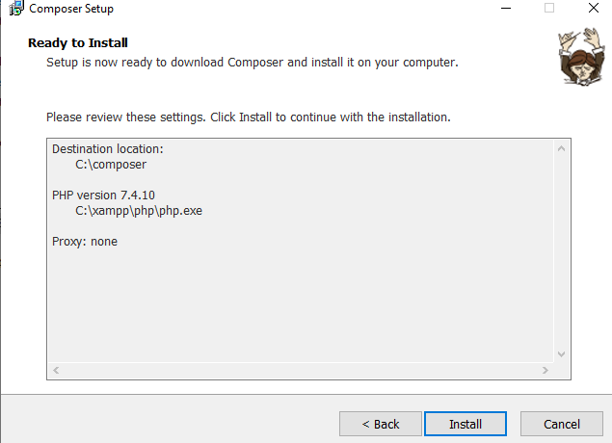

* 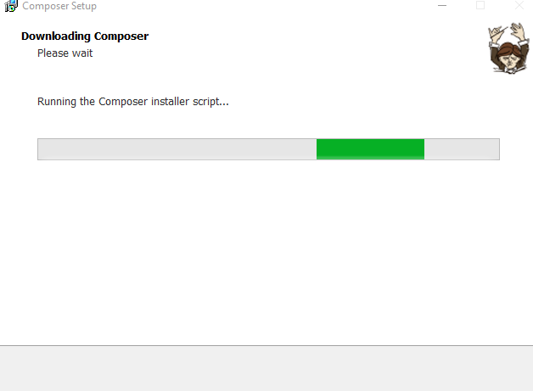

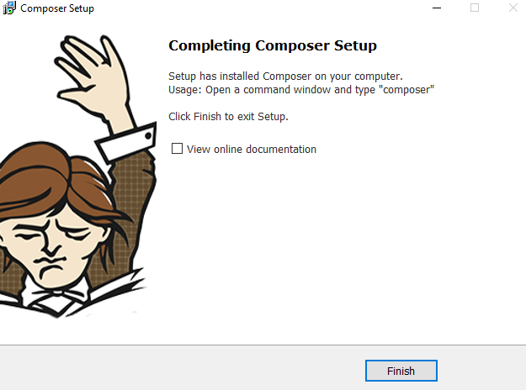

To check whether composer is installed or not : open **cmd** type **composer –v**

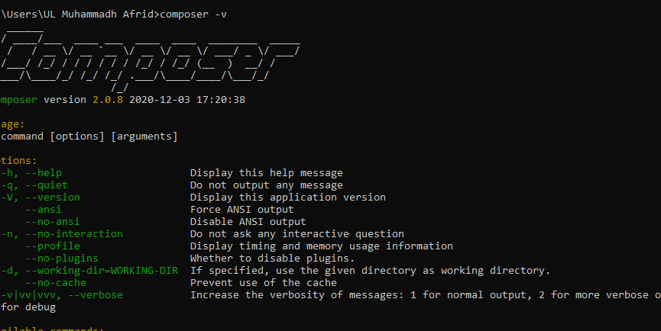

* **Installing laravel**

Laravel is installed using composer in cmd or visual code terminal.



A new project created by, (Laravel should be installed already)



Or we can simply create project using composer command,



**Set up .env**

Set environment for database with database name.

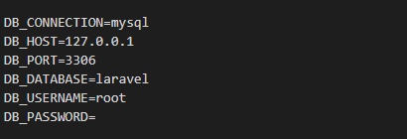

Set environment to send email

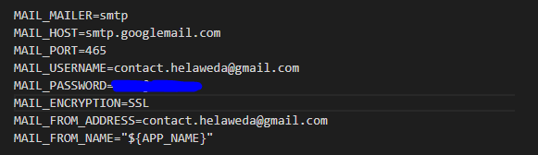

**Basic Codes**

* **php artisan serve** - Run the project in localhost at 127.0.0.1 and port number 8000
* **php artisan make:controller <controller name>** – Create controllers.
* **Php artisan make:model <model name>** - Create models.
* **Php artisan migrate** – Migrate database model with tables.
* **Php artisan migrate:fresh** – Drop all database models and remigrate.
* **Php artisan db:seed** – Record data into database from seeder.

**How to clone the project from github repository.**

When you create a repository on GitHub, it exists as a remote repository. You can clone your repository to create a local copy on your computer and sync between the two locations.

This procedure assumes you have already created a repository on GitHub, or have an existing repository owned by someone else you'd like to contribute to.

1. On GitHub, navigate to the main page of the repository.

2. Under the repository name, click Clone or download.

3. In the Clone with HTTPs section, click to copy the clone URL for the repository.

4. Open Git Bash.

5. Change the current working directory to the location where you want the cloned directory to be made.

6. Type git clone, and then paste the URL you copied in Step 2.

7. Press Enter. Your local clone will be created.

**URLs and methods.**

|  |  |  |
| --- | --- | --- |
| URL | Type of Method | Outcome |
| /welcome | Get | Redirect to home page |
| /register | Get | Redirect to registration page of patient |
| /saveuser | Post | Submitting registering details of patients. |
| /login | Get | Redirect to login page |
| /log | Post | Submitting login form details. |
| /enter/id | Post | When open a browser in case if user did not logout from last login, it will redirect to corresponding user profile. |
| /logout | Get | Logout |
| /forgot | Get | Redirect to forget password action doing page. |
| /forgotpass | Post | Submit details from forgot password page. |

**Doctors**

|  |  |  |
| --- | --- | --- |
| URL | Type of Method | Outcome |
| /docedit | Post | When a doctor edits his profile data go through this link. |
| dochome/{c}/ | Get | Redirect a doctor to his home page. |
| prescription/{c}/ | Get | Redirect a doctor to prescription page. |
| admitted/{c}/ | Get | Redirect a doctor to admitted patients’ records page. |
| available/{c}/ | Get | Redirect a doctor to available time periods page. |
| addpatdetails/{c}/ | Get | Redirect a doctor to patient admitting page. |
| /savepres | Post | Saves a prescription that doctor wrote. |
| /saveadmit | Post | Saves a record about admitted patient. |
| /pressearch | Post | Returns search results of prescriptions. |
| /adsearch | Post | Returns search results of admitted patients’ records. |
| /saveavailable | Post | Saves an available time period. |
| /avedit method | Post | To edit an available time period. |
| /avdelete/{id}/{docid} | Get | To delete an available time period. |
| /patadmit | Post | Saves details of newly admitted patient. |
| /admitsearch | Post | Returns search results of admitted patients. |
| docsymp/{c}/ | Get | Redirects a doctor to medical symptoms page |
| docviewSymp/{i}/{j}/ | Get | Redirects a doctor to view details of a medical symptom. |
| /docreply | Post | Update doctor’s reply for a medical symptom. |
| appointment/{c}/ | Get | Redirects a doctor to appointments page. |
| /appsearch | Post | Returns search results of appointments. |
| /docpic | Post | Update profile picture of a doctor. |
| discharge/{c}/{d} | Post | Discharges an admitted patient. |

**Patients**

|  |  |  |
| --- | --- | --- |
| URL | Type of Method | Outcome |
| /pathome/pat1 | Get | A patient after login, redirect to his profile. |
| /patedit | Patch | When a patient edits his profile data go through this link. |
| /changeprofile/pat1 | Patch | Patient change his profile picture. |
| /symp/pat1 | Get | Patient (pat1) is redirected to symptom adding page. |
| /addsymptomps/pat1 | Post | Patient (pat1) is submitting his medical symptoms to doctor. |
| /order/pat1 | Get | Patient (pat1) is redirected to order medicine page. |
| /ordermedicine/pat1 | Post | Order medicine to pharmacist. |
| /book/pat1 | Get | Redirect a particular patient into book a doctor page. |
| /showAvail | Get | Filter doctors’ available time by patient wish |
| /appoint | Get | Redirect to page which shows available time for doctors. |
| /confirmAppoinment | Post | When a patient confirm his appointment, it will be sent through this link |
| /deleteAppoint | Get | Delete doctors’ appointment. |
| /history/pat1 | Get | A patient sees his medical history. |

**Pharmacist**

|  |  |  |
| --- | --- | --- |
| URL | Type of Method | Outcome |
| /phahome/pha1 | Get | After login as pharmacist, redirect to pharmacist profile page. |
| /phaedit | Post | When a pharmacist edits his profile data go through this link. |
| /pharprofilepic/pha1 | Patch | Pharmacist changes his profile picture. |
| /medicalstock/pha1 | Get | Redirect a pharmacist to medical stock page |
| /addmedicine | Post | Add new medicine into pharmacist medical stock. |
| /updatemedicine/pha1 | Post | Update existing medicine stock details in pharmacist medicine stock. |
| /Delmedicine/pha1 | Post | Delete a medicine from pharmacist medical stock. |
| /issueMedicine/pha1 | Get | Redirect a pharmacist to issue medicine page. |
| /Issuepatorder/pha1 | Post | Issuing medicine order from patient online orderings. |
| /issuedocorder/pha1 | Post | Issuing medicine from doctor’s prescription. |
| /phaordermedicine/pha1 | Get | Redirect pharmacist to pharmacist medicine ordering page. |
| Ordertopro/pha1 | Post | Order medicine to producer from pharmacist. |

**Medicine producer**

|  |  |  |
| --- | --- | --- |
| URL | Type of Method | Outcome |
| mphome/{c}/ | Get | Redirects a medicine producer to his profile home page. |
| issuemedicine/{c}/ | Get | Redirects a medicine producer to issue medicine orders page. |
| Ingstock/{c}/ | Get | Redirects a medicine producer to ingredients stock page. |
| medstock/{c}/ | Get | Redirects a medicine producer to his medicine stock page. |
| ordering/{c}/ | Get | Redirects a medicine producer to order ingredients page. |
| /proedit | Post | Edits profile of medicine producer. |
| /proaddmedicine | Post | Add new medicine stock. |
| /proupdatemedicine | Post | Update existing medicine stock details. |
| /promeddelete/{c}/{d} | Get | Delete a medicine stock. |
| /proadding | Post | Add a new ingredient stock. |
| /proingdelete/{c}/{d} | Get | Delete an ingredient stock. |
| /proupdateing | Post | Update details of existing ingredient stock. |
| /proingorder | Post | Place an ingredient order to ingredient supplier. |
| /ordersearch | Post | Return search result of ingredient orders. |
| /issusearch | Post | Return search result of issue medicine. |
| reorder/{c}/{d} | Get | Issue a medicine order. |
| medicines/{c}/ | Get | Redirect a medicine producer to medicine details page. |
| /newmedicine | Post | Add a new medicine. |

**Ingredient supplier**

|  |  |  |
| --- | --- | --- |
| URL | Type of Method | Outcome |
| suphome/{c}/ | Get | Redirect an ingredient supplier to his profile home page. |
| /supedit | Post | Edit profile of ingredient supplier. |
| /suppic | Post | Edit profile picture of ingredient supplier. |
| issueing/{c}/ | Get | Redirect an ingredient supplier to issue ingredient orders page. |
| newing/{c}/ | Get | Redirect ingredient supplier to add new ingredient page. |
| supreorder/{c}/{d} | Get | Issue an ingredient order. |
| /newingredient | Post | Add new ingredient. |
| /issuingsearch | Post | Return search results of ingredient orders. |

**Admin**

|  |  |  |
| --- | --- | --- |
| URL | Type of Method | Outcome |
| /adminpage/adminid | Get | Redirect to home page of admin. |
| /admedit | Post | Edit profile of admin |
| /regist/adminid | Get | Redirect to users’ registration page. |
| /addnew | Post | Create new user (doctor/pharmacist/medicine producer, ingredient supplier). |
| /profit/adminid | Get | Redirect to profit view page. |
| /patbill | Post | When admin use any filters in viewing profits from patient medicine orders. |
| /patbill | Get | When admin search with no filters in patient medicine orders, it will provide all details. |
| /docbill | Get | When admin use any filters in viewing profits from doctors medicine prescription. |
| /docbill | Get | When admin search with no filters in doctors’ medicine prescription, it will provide all details. |
| /profview/adminid | Get | View users’ profile by Admin. |

**Database models**

* AllUsers : Allusers details.
* Doctor: save doctors’ details
* Ingredient_supplier: save supplier details.
* Medicine_producer: save medicine producer’s details.
* Patient: save patients’ details.
* Pharmacist: save pharmacists’ details.
* admin: save admin details.
* Add_pat_up : Admitted patients updates.
* Add_pat : Add new patient to ward.
* add_symptomps : Store medical symptoms
* Doc_available_time : save doctors’ available time
* Ingredient_ordering : save ingredients orders details from medicine producer.
* Ingredient_stock : ingredient stock details in producer.
* Ingredients: maintain all ingredient details by supplier.
* Medical_history : medical histories of outpatients.
* Medicine_ordering : save medicine orders details from pharmacist to producer.
* Medicine_stock : medicine stocks pharmacist.
* Medicines: maintain all medicines details by medicine producer.
* new_med_stock : medicine stock of medicine producer.
* OnlineBooking : save patients’ online booking details.
* pat_med_ordering : save patients’ medicine ordering details.

**Controllers**

* AdminController : control all admin backend activities.
* patientsController : control all patients backend activities.
* pharmacistController : control all pharmacists backend activities.
* login : control login parts’ backend activities of all users.
* PageController : control redirecting activities of login, register and logout functions.
* redirect : control all backend activities of redirecting parts pages of doctors, medicine producer and ingredient supplier.
* search : control backend activities of searching functions of doctors, medicine producer and ingredient supplier.
* store : control backend activities of new record creating functions of doctors, medicine producer and ingredient supplier.
* update : control backend activities of update existing records functions of doctors, medicine producer and ingredient supplier.

**Test Cases**

|  |  |  |  |  |
| --- | --- | --- | --- | --- |
| Test ID | Test scenario | Test data/Action | Expected Output | Actual Output |
| 001 | Login with correct credentials | User id: pat1  Password: pat1@ | Redirect to Profile page of pat1. | Redirected to profile page of pat1. |
| 002 | Login with correct user id and false password | User id: pat1  Password: xyza | Show warning message | Shown as wrong password or username. |
| 003 | Login with empty fields | User id:  Password: | Show warning message | Shown as wrong password or username. |
| 004 | Doctor adds prescription to non-existing patient. | Pat id : pat90000  Disease: fever  Diagnosis: headache  Medicine : panadol | Show “The patient doesn’t exist.” | Shown, “The patient doesn’t exist.” |
| 005 | Doctor searching admitted patient record with false patient id. | Pat id: pat 578585 | Nothing will be shown | Table is empty and shown “No Records Found” |
| 006 | Pharmacist issue ordered medicine from patient and prescribed medicine from doctors. | Press issue order in issue medicine page. | Quantity of issued medicine will be reduced in medicine stock. | Quantity of issued medicine was reduced in medicine stock and marked as issued. |
| 007 | Medicine producer issue ordered medicine from pharmacists. | Press issue order in issue medicine page. | Quantity of issued medicine will be reduced in medicine stock. | Quantity of issued medicine was reduced in medicine stock and issue button changed as issued. |
| 008 | Admin registers users. | Fill all field of users details. | User id and password will be sent to his mail. | User id and password was sent to his mail. |
| 009 | When a user already logged in, accessing login page. | Redirecting login page manually. | It will be redirected to already logged in user’s profile. | It was redirected to already logged in user’s profile. |
| 010 | Logout then come back and do an action | Log out and come back and do an action. | It will be redirected to login page. | It was redirected to login page with warning login first. |